Rutuja Vijay Jagtap

Superset id:1367907

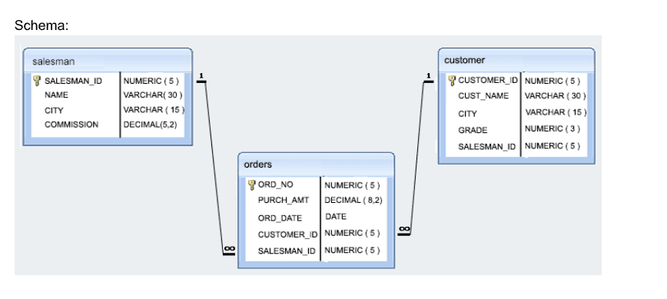

Create table Salesman

(

Salesman_id numeric,

Salesman_Name varchar(30),

City varchar(15),

Commission Decimal(5,2)

primary key(Salesman_id)

)

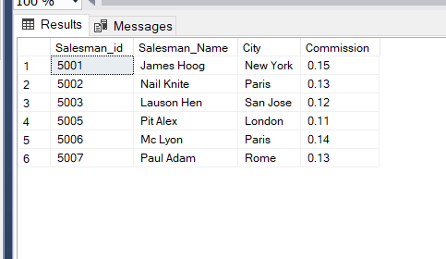

Create table Orders

(

Order_No numeric,

Purch_Amt Decimal(8,2),

Order_Date Date,

Customer_id numeric,

Salesman_id numeric

primary key(Order_No)

)

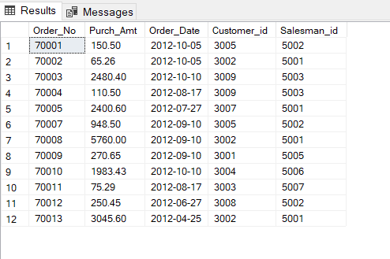

Create table Customer

(

Customer_id numeric,

Customer_Name varchar(30),

City varchar(15),

Grade numeric,

Order_No numeric,

Purch_Amt Decimal(8,2),

Salesman_id numeric

primary key(Customer_id)

)

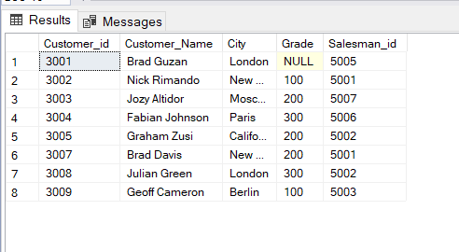

**1)Write a query to display the columns in a specific order like order date,**

**salesman id, order number and purchase amount from for all the orders**

select Order_Date,Salesman_id,Order_No from Orders

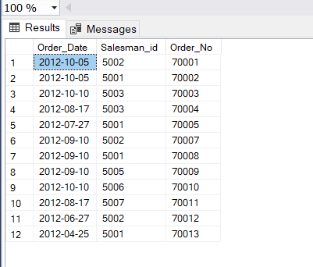

**2. write a SQL query to find the unique salespeople ID. Return salesman_id.**

Select distinct Salesman_id from Salesman

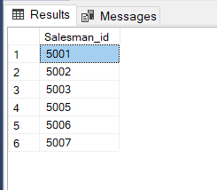

**3. write a SQL query to find the salespeople who lives in the City ofnew york,Paris & berlin.**

**Return salespersons name, city**

Select Salesman_Name, City from Salesman where City='New York' or City='Paris' or City='Berlin'

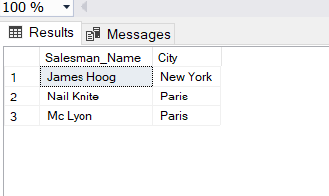

**4. write a SQL query to find the orders, which are delivered by a salesperson of ID. 5001. Return ord_no, ord_date, purch_amt**

Select Order_No,Order_Date,Purch_Amt from Orders where Salesman_id=5001

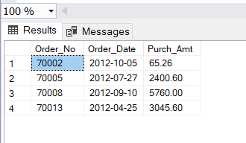

**5. write a SQL query to find all the customers in ‘New York’ city who have a**

**grade value above 100. Return customer_id, cust_name, city, grade, and**

**Salesman_id.**

Select Customer_id, Customer_Name , City,Grade , Salesman_id from Customer where city='New York' and grade>100

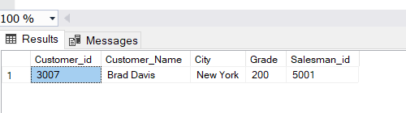

**6. write a SQL query to find the details of those salespeople whose**

**commissions range from 0.10 to0.12. Return salesman_id, name, city, and**

**Commission**

Select * from Salesman where Commission between 0.10 and 0.12

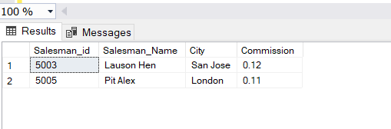

**7. write a SQL query to calculate total purchase amount of all orders. Return total purchase amount.**

select sum(Purch_Amt) from Orders

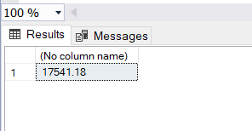

**8. write a SQL query to calculate average purchase amount of all orders.**

**Return average purchase amount.**

Select avg(Purch_Amt) from Orders

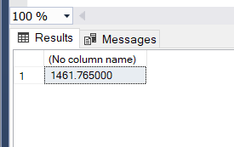

**9. write a SQL query to count the number of unique salespeople. Return**

**number of salespeople.**

Select count(Salesman_id) from Salesman

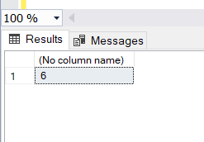

**10. write a SQL query to find the highest purchase amount ordered by**

**each customer. Return customer ID, maximum purchase amount**

SELECT Customer_id, MAX(Purch_Amt)

FROM Orders

GROUP BY Customer_id;

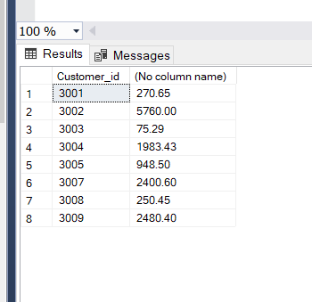

**11. write a SQL query to find the highest purchase amount ordered by**

**each customer on a particular date. Return, order date and highest**

**purchase amount**

SELECT Customer_id,Order_Date,MAX(Purch_Amt) FROM Orders GROUP BY Customer_id,Order_Date;

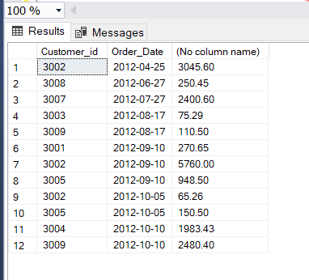

**12. write a SQL query to find the highest purchase amount on &#39;2012-08-**

**17&#39; by each salesperson. Return salesperson ID, purchase amount.**

Select Salesman_id, max(Purch_Amt) from Orders where Order_Date='2012-08-17' group by Salesman_id

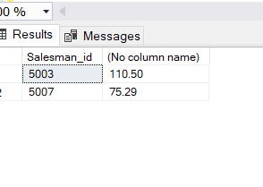

**13. write a SQL query to find the salesperson and customer who**

**belongs to same city. Return Salesman, cust_name and city.**

SELECT Salesman_Name AS "Salesman",

Customer.Customer_Name, Customer.City

FROM Salesman,Customer

WHERE Salesman.City=Customer.City;

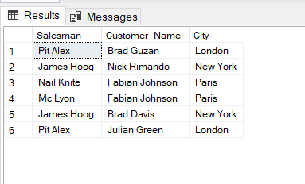

**14. write a SQL query to find those orders where order amount exists**

**between 500 and 2000. Return ord_no, purch_amt, cust_name, city**

Select Orders.Order_No, Orders.Purch_Amt, Customer.Customer_Name, Customer.City from Orders,Customer where Purch_Amt between 500 and 2000

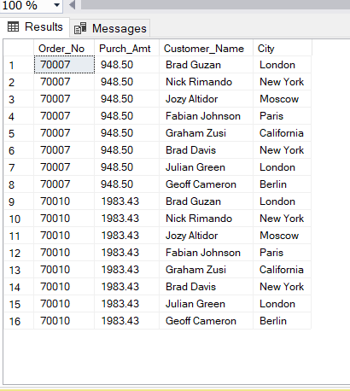

**15. write a SQL query to find those salespersons who received a**

**commission from the company more than 12%. Return Customer Name,customer city, Salesman, commission**

Select Customer.Customer_Name,Customer.City, Salesman.Salesman_Name, Salesman.Commission from Customer, Salesman where Salesman.Commission>0.12

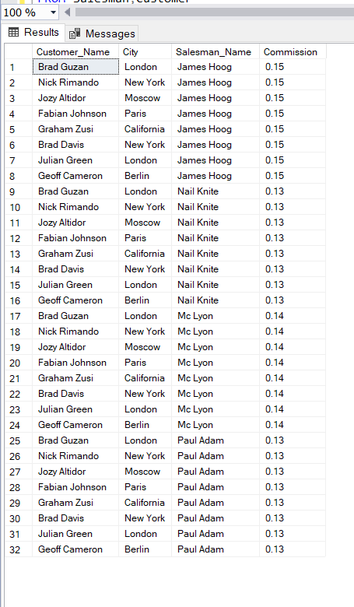

**16. write a SQL query to display the cust_name, customer city, grade,**

**Salesman, salesman city. The result should be ordered by ascending on**

**customer_id.**

Select Customer.Customer_Name,Customer.City,Customer.Grade,Salesman.Salesman_Name,Salesman.City from Customer, Salesman Order by Customer.Customer_id

